**FRIO COUNTY COMMISSIONERS COURT MINUTES FOR**

**Regular Meeting May 30th, 2023**

On the 30th day of May, 2023, at 3:00 p.m., the Commissioners Court of Frio County met in a regular meeting with the following members either absent or present, to-wit: Rochelle Lozano Camacho, Frio County Judge was present; Joe Vela, Commissioner Pct 1 present; Mario Martinez, Commissioner Pct 2 present; Raul Carrizales, Commissioner Pct 3 present; Danny Cano, Commissioner Pct 4 present; Joseph A. Sindon, Legal Counsel for Frio County Commissioners Court present; and Aaron Ibarra, Frio County Clerk present when the following meeting was held, to-wit:

I. Invocation and Pledge of Allegiance

II. Adopt Agenda

**MOTION: COMMISSIONER CARRIZALES**

**SECOND: COMMISSIONER MARTINEZ**

**MOTION PASSED**

III. Old Business

**PRESENTATION**

**ACTION AGENDA ITEMS**

IV. General Discussion-

V. Citizens To Be Heard

**NONE**

VI. New Business

**PRESENTATION**

(1) Ronald Rocha, Attorney at Law, Linebarger Goggan Blair & Sampson, LLP**,** requests:

Update on the delinquent fines and collection services by Linebarger Goggan Blair & Sampson LLP.

**ITEMS DISCUSSED AND PRESENTED. NO FURTHER ACTION TAKEN**

(2) Hon. Raul Carrizales, III. Frio County Commissioner, Precinct No. 3, requests:

Presentation of monthly statistics reports compiled by ShureMed.

**ITEMS DISCUSSED AND PRESENTED. NO FURTHER ACTION TAKEN**

(3) Rick Garcia and Robert Vierra, Ardurra, request:

Presentation regarding the services offered by Ardurra.

**ITEMS DISCUSSED AND PRESENTED. NO FURTHER ACTION TAKEN**

**ACTION AGENDA ITEMS**

(1) Hon. Mike Morse, Frio County Sheriff, requests:

1.1 Consider/take action on opening and reviewing RFQ submissions for design/build services to assist Frio County with building renovation and to evaluate building energy consumption received by the specified deadline.

1.2 Consider/take action on selecting and approving the preferred RFQ submission for design/build services to assist Frio County with building renovation and to evaluate building energy consumption that were received by the specified deadline.

**ULTIMATELY NO ACTION WAS TAKEN, WILL BE BROUGHT BACK NEXT AGENDA.**

(2) Chris Watson, Senior Energy Advisor and Government Entity Specialist, 5, requests:

2.1 Present energy rates from electricity suppliers.

2.2 Consider / take action on selecting electricity supplier and contract.

2.3 Approve granting the County Judge authority to sign an electricity contract on behalf of Frio County.

**MOTION TO APPROVE 2.2, 2.3 IF 3-60 MONTH, IF .05449 RATE**

**FIRST: COMMISSIONER CARRIZALES**

**SECOND: COMMISSIONER CANO**

**MOTION PASSED**

(3) Denise Woody, Frio County Emergency Services District Administrator, requests:

3.1 Consider/take action on accepting the resignation of Luciano Luna from the Frio County Emergency Services District Board.

**MOTION: COMMISSIONER MARTINEZ**

**SECOND: COMMISSIONER CARRIZALES**

**MOTION PASSED**

3.2 Consider/take action on appointing an eligible Frio County Resident to serve 2 years on the Frio County Emergency Services District Board.

**3.2 WILL BE PLACED ON NEXT AGENDA.**

(4) Hon. Pete Jasso Martinez, Frio County Treasurer, requests:

4.1 Consider/take action on approving a Depository Contract with Security State Bank and all related documents.

4.2 If contract is approved, consider/take action on signing resolution allowing Frio County Judge Rochelle Camacho to enter into same and all other necessary documents on behalf of Frio County.

**FIRST: COMMISSIONER CARRIZALES**

**SECOND: COMMISSIONER CANO**

**MOTION PASSED**

(5)  Hon. Rochelle Camacho, Frio County Judge, requests:

Consider and act on accepting a donation from AAGOG- Area Agency on Aging, a total of 30 box fans for the use by the elderly/disabled.

**MOTION: COMMISSIONER CARRIZALES**

**SECOND: COMMISSIONER MARTINEZ**

**MOTION PASSED**

(6)  Hon. Rochelle Camacho, Frio County Judge, requests:

Discuss, Consider, and take action on selecting a planning and management service provider(s) to complete application and project implementation for the Community Development Block Grant-Mitigation (CDBG-MIT) Local Hazard Mitigation Plans Program (LHMPP) funding administered by the Texas General Land Office.

**NO ACTION, NEXT AGENDA**

(7)  Hon. Rochelle Camacho, Frio County Judge, requests:

Consider/take action on approving a Resolution Calling for Additional Measures to Secure the Border, Stop the Invasion at the Border, and Protect Our Communities.

**ITEM WAS CUT FROM AGENDA AT THE REQUEST OF THE JUDGE, NO DISCUSSION.**

(8)  Hon. Rochelle Camacho, Frio County Judge, requests:

Consider/take action on proclaiming May 2023 to be recognized as Elder Abuse Prevention Month and sign proclamation stating same.

**MOTION: COMMISSIONER MARTINEZ**

**SECOND: COMMISSIONER CARRIZALES**

**MOTION PASSED**

(9) Hon. Joe Vela, Frio County Commissioner, Precinct No. 4, requests:

Discussion regarding installed stop signs in Derby.

**ITEM WAS DISCUSSED AT LENGTH**

(10) Hon. Joe Vela, Frio County Commissioner, Precinct No. 4, requests:

Consider/take action to authorize initial contract with Medina electric for security lights on the following roads in Derby:

1. CR 4401 & CR 4427
2. CR 4401 & CR 4425
3. CR 4401 & CR 4402
4. FM 1583 & CR 3416
5. CR 3410 & CR 3435
6. CR 3415 & CR 3430
7. CR 3416 & CR 3428
8. CR 3420 & CR 3428
9. CR 3418 & CR 3424
10. CR 3414 & CR 3415

**MOTION: COMMISSIONER VELA**

**SECOND: COMMISSIONER CARRIZALES**

**MOTION PASSED**

(11) Hon. Mario Martinez, Frio County Commissioner, Precinct No. 2, requests:

Consider/take action to authorize initial contract with Medina electric for security lights on Sand Hollow Rd./CR 2000.

**MOTION: COMMISSIONER MARTINEZ**

**SECOND: COMMISSIONER CANO**

**MOTION PASSED**

(12) Hon. Danny Cano, Frio County Commissioner, Precinct No. 4, requests:

Consider/take action executing a memorandum of donation and accepting and taking into custody 8,000 CY of Recycled Asphalt Pavement (RAP) from the TxDOT Routine Maintenance Project located at mile marker 38 on Interstate 35 in La Salle County, Texas.

**MOTION: COMMISSIONER CANO**

**SECOND: COMMISSIONER VELA**

**MOTION PASSED**

(13) Ancelmo Ornelas, Frio County Road and Bridge Administrator, requests:

Consider/take action on approving waiving the fees for nonprofit organization, VFW Post 9195 for fundraiser to be held on November 11, 2023 @ Fireman’s Park (please see attached application).  Will be having a car show, live music and will be cooking for veteran’s and family members.

**MOTION: COMMISSIONER MARTINEZ**

**SECOND: COMMISSIONER CANO**

**MOTION PASSED**

(14) Ancelmo Ornelas, Frio County Road and Bridge Administrator, requests:

14.1 Consider/take action on approving a quote from Anderson Columbia Co., Inc. for the amount of $13,200.00 for ¾ road base material.  Material will be used on Derby area roads.

14.2 Consider/take action on approving a quote from Anderson Columbia Co., Inc. for the amount of $13,750.00 for ¾ road base material.  Material will be used for County wide road base repairs.

**MOTION: COMMISSIONER CARRIZALES**

**SECOND: COMMISSIONER VELA**

**MOTION PASSED**

(15) Hon. Mike Morse, Frio County Sheriff, requests:

Discuss and approve payment on the Damaged Property subsidy request by Jeff Brymer, the land owner.

**MOTION: COMMISSIONER MARTINEZ**

**SECOND: COMMISSIONER CANO**

**MOTION PASSED**

(16) Hon. Crystal Marquez, Frio County Auditor, requests:

16.1 Consider / take action on approving the CIAC agreement with American Electric Power Texas (A.E.P), and installation costs of $658.06 to install five 122-watt LED street lights at CR 2000 and Berry Ranch Road at CR 2016 and 2017 in Pearsall, Texas.

16.2 If the CIAC Agreement is approved, consider/take action on approving a resolution authorizing Hon. Rochelle Camacho, Frio County Judge, to sign same on behalf of Frio County.

**MOTION: COMMISSIONER MARTINEZ**

**SECOND: COMMISSIONER CARRIZALES**

**MOTION PASSED**

(17) Hon. Crystal Marquez, Frio County Auditor, requests:

17.1 Consider / take action on approving Services Order Agreement with Spectrum Enterprise for 10 new native BCP lines for a total monthly cost of $590.88 and a one-time installation fee of $99.00 at 500 E. San Antonio St., Pearsall, Texas.

17.2 If the Services Order Agreement is approved, consider/take action on approving a resolution authorizing Hon. Rochelle Camacho, Frio County Judge, to sign same on behalf of Frio County.

**MOTION: COMMISSIONER CARRIZALES**

**SECOND: COMMISSIONER CANO**

**MOTION PASSED**

(18) Hon. Crystal Marquez, Frio County Auditor, requests:

18.1 Consider / take action to approve the budget amendments to the FISCAL YEAR 2022-2023 Frio County Budget, list below:

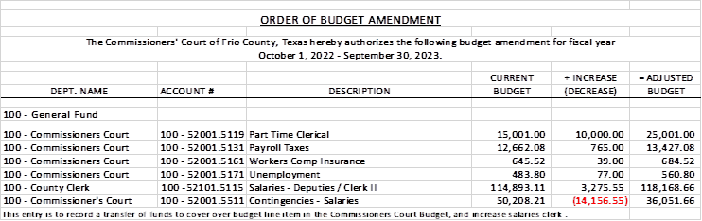

18.2 If the amendment is approved, consider/take action on signing order stating same.

**MOTION: COMMISSIONER MARTINEZ**

**SECOND: COMMISSIONER VELA**

**MOTION PASSED**

(19) Hon. Crystal Marquez, Frio County Auditor, requests:

19.1 Consider / take action to approve the budget amendments to the FISCAL YEAR 2022-2023 Frio County Budget, list below:

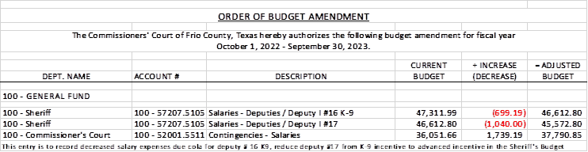

19.2 If the amendment is approved, consider/take action on signing order stating same.

**MOTION: COMMISSIONER CARRIZALES**

**SECOND: COMMISSIONER CANO**

**MOTION PASSED**

(20) Hon. Crystal Marquez, Frio County Auditor, requests:

20.1 Consider / take action to approve the budget amendments to the FISCAL YEAR 2022-2023 Frio County Budget, list below:

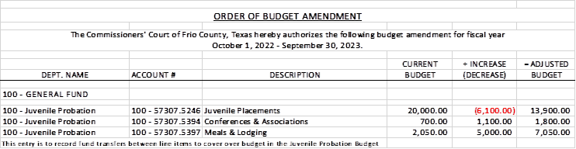

20.2 If the amendment is approved, consider/take action on signing order stating same.

**MOTION: COMMISSIONER CARRIZALES**

**SECOND: COMMISSIONER CANO**

**MOTION PASSED**

(21) Hon. Crystal Marquez, Frio County Auditor, requests:

21.1 Consider / take action to approve the budget amendments to the FISCAL YEAR 2022-2023 Frio County Budget, list below:

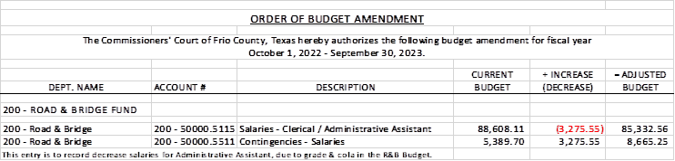

21.2 If the amendment is approved, consider/take action on signing order stating same.

**MOTION: COMMISSIONER MARTINEZ**

**SECOND: COMMISSIONER CARRIZALES**

**MOTION PASSED**

(22) Hon. Aaron Ibarra, Frio County Clerk, requests:

22.1 Consider/ take action on authorizing execution by Frio County Judge of a contract between Department of State Health Services and Frio County, Texas for a five (5) year term and ending on August 31, 2027. Contract will allow Frio County to have access to Texas Electronic Registration Remote System for the purpose of issuing individual birth certificates.

22.2 If the contract is approved, then sign a resolution authorizing Frio County Judge Rochelle Camacho to enter into said agreement on behalf of Frio County.

**MOTION: COMMISSIONER MARTINEZ**

**SECOND: COMMISSIONER CARRIZALES**

**MOTION PASSED**

(23) Hon. Danny Cano, Frio County Commissioner, Precinct No. 4, requests:

Consider/take action on removing the speed humps located on County Road 4670 aka Cemetery Road in Dilley, Texas.

**MOTION: COMMISSIONER CANO**

**SECOND: COMMISSIONER CARRIZALES**

**MOTION PASSED**

(24)  Hon. Rochelle Camacho, Frio County Judge, requests:

24.1 Interview applicants for the Frio County Engineer Position.

24.2 Consider/take action on selecting an applicant for the Frio County Human Resources Director position.

**NO ACTION**

(25) Documents (resolutions, orders, contracts, etc.) to be signed.

**REVIEWED AND SIGNED**

(26) Allow bills payable

**REVIEWED AND PAID**

(27) Adjourn

**MOTION: COMMISSIONER CARRIZALES**

**SECOND: COMMISSIONER MARTINEZ**

**MOTION PASSED**

**APPROVED:**

**_____________________________________  
  
_____________________________________  
  
_____________________________________  
  
_____________________________________  
  
_____________________________________**